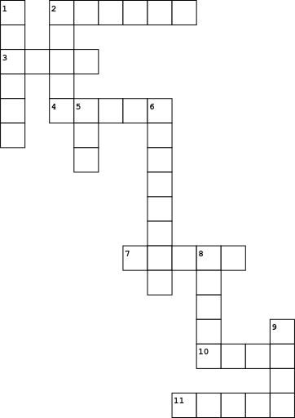

|  |  |  |  |
| --- | --- | --- | --- |
| **Across** | | Down | |
|  | |  | |
| 2. |  | 1. |  |
| 3. |  | 2. |  |
| 4. |  | 5. |  |
| 7. |  | 6. |  |
| 10. |  | 8. |  |
| 11 |  | 9. |  |